- What is Java?
Ans:- Java technology is both a programming language and a platform from Oracle Corporation.
- Why Java is called as “Platform”?
ans:- A platform is basically the hardware or software environment in which a program runs. Java provides software-based platform i.e. JVM, which can run applications developed using the Java Programming Language.

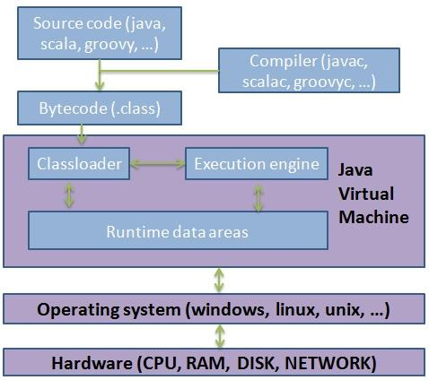

- What are the features of Java ?

Ans:- Features of Java

1) Simple
Simple syntax. No pointers, no multiple inheritance with the classes which causes ambiguity error. For almost every task API (Application Programming Interface) is available; Programmer just need to know how to use that API.

2) Object Oriented
Java is strong object oriented as it does not allow features like global data, friend function which are against OOP principles.

3) Automatic Garbage Collection:
Automatic garbage collection is the process of looking at heap memory, identifying which objects are in use and which are not, and deleting the unused objects. An in use object, or a referenced object, means that some part of your program still maintains a reference to that object. An unused object, or unreferenced object, is no longer referenced by any part of your program. So the memory used by an unreferenced object can be reclaimed.

3) Robust
Robust means safe. Java puts a lot of emphasis on early checking for possible errors, as Java compilers are able to detect many problems that would first show up during execution time in other languages.
It provides the powerful exception handling and type checking mechanism as compare to other programming languages.

4) Platform Independent
Unlike other programming languages such as C, C++ etc which are compiled into platform specific machines. Java is guaranteed to be compile-once, run-anywhere language.
On compilation Java program is compiled into bytecode. This bytecode is platform independent and can be run on any machine. Any machine with Java Runtime Environment can run Java Programs.
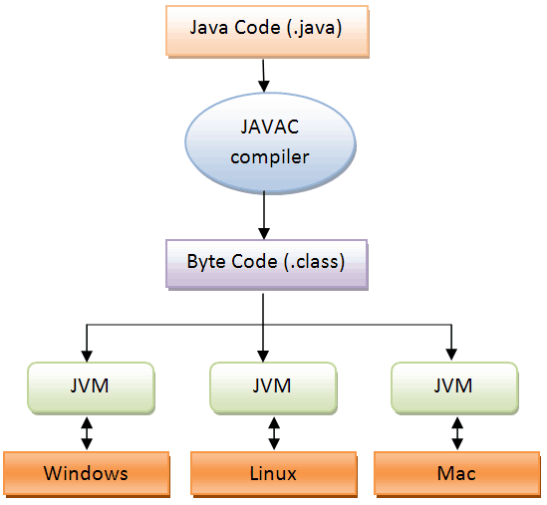

5) Secure
If a bytecode contains any virus or malicious code, JVM will not execute it. This features saves your system especially when u download java code and try to execute.

6) Multi Threading
Java multithreading feature makes it possible to write program that can do many tasks simultaneously.

7) Portable
Java Byte code can be carried to any platform.

8) Architectural Neutral
No implementation dependent features. Everything related to storage is predefined, example: size of primitive data types is same on all the platforms.

8) High Performance
Java enables high performance with the use of Just-In-Time (JIT) compiler.

- How java is platform independent ?
Ans:- Java program, once compiled , can be run on any platform without recompiling.

- Which version of java have u learned? Name some of the new features added to it.
Ans:- java8 version. Some of the new features are:

- default methods and static methods inside interface

- lambda expressions

- method reference

- stream api

6) What is native code?
Ans:- Native code is computer programming (code) that is compiled to run with a particular processor (such as an Intel x86-class processor) and its set of instructions.

- What is the difference bet’n JDK and JRE.
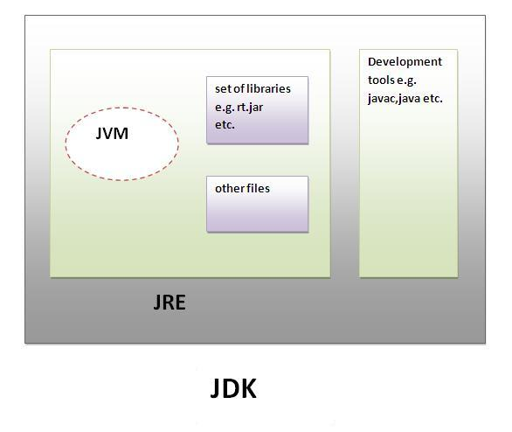
JRE is an acronym for Java Runtime Environment. It is used to provide runtime environment. It contains JVM + API ( jars and dlls)
JDK is an acronym for Java Development Kit. It contains JRE + development tools like compiler,debugger etc.

- What is JVM ? What it does?
Ans:- A Java virtual machine (JVM), an implementation of the Java Virtual Machine Specification, interprets compiled Java binary code (called bytecode) for a computer's processor (or "hardware platform") so that it can perform a Java program's instructions. Java was designed to allow application programs to be built that could be run on any platform without having to be rewritten or recompiled by the programmer for each separate platform.
JVMs are available for various platforms (i.e.JVM is platform dependent).

It is:
- A specification where working of Java Virtual Machine is specified. But implementation provider is independent to choose the algorithm. Its implementation has been provided by Sun and other companies.
- An implementation Its implementation is different for different platforms.
- Runtime Instance Whenever you write java command on the command prompt to run the java class, an instance of JVM is created.

The JVM performs following operation:
- Loads code
- Verifies code
- Executes code

- Why JVM is called as “virtual machine”?
Ans:- The JVM is "virtual" because it is generally implemented in software on top of a "real" hardware platform and operating system. All Java programs are compiled for the JVM. Therefore, the JVM must be implemented on a particular platform before compiled Java programs will run on that platform.

- What is the lifetime of Java Virtual Machine ?
Ans:- When a Java application starts, a runtime instance of JVM is born. When the application completes, the instance dies.

- What are the main components of JVM? Explain them. Or Explain JVM Architecture.
Ans:- a) ClassLoader Subsystem b) Various Runtime Data Areas c) Execution Engine

JVM(Java Virtual Machine) acts as a run-time engine to run Java applications. JVM is the one that actually calls the main method present in a java code. JVM is a part of JRE(Java Runtime Environment).
Java applications are called WORA (Write Once Run Anywhere). This means a programmer can develop Java code on one system and can expect it to run on any other Java-enabled system without any adjustment. This is all possible because of JVM.
When we compile a .java file, .class files(contains byte-code) with the same class names present in .java file are generated by the Java compiler. This .class file goes into various steps when we run it. These steps together describe the whole JVM.

Class Loader Subsystem
It is mainly responsible for three activities.
- Loading
- Linking
- Initialization

Loading: The Class loader reads the “.class” file, generate the corresponding binary data and save it in the method area. For each “.class” file, JVM stores the following information in the method area.
- The fully qualified name of the loaded class and its immediate parent class.
- Whether the “.class” file is related to Class or Interface or Enum.
- Modifier, Variables and Method information etc.
After loading the “.class” file, JVM creates an object of type Class to represent this file in the heap memory. Please note that this object is of type Class predefined in java.lang package. These Class object can be used by the programmer for getting class level information like the name of the class, parent name, methods and variable information etc. To get this object reference we can use getClass() method of Object class.
- Java
// A Java program to demonstrate working
// of a Class type object created by JVM
// to represent .class file in memory.
import java.lang.reflect.Field;
import java.lang.reflect.Method;

// Java code to demonstrate use
// of Class object created by JVM
public class Test {
public static void main(String[] args)
{
Student s1 = new Student();

// Getting hold of Class
// object created by JVM.
Class c1 = s1.getClass();

// Printing type of object using c1.
System.out.println(c1.getName());

// getting all methods in an array
Method m[] = c1.getDeclaredMethods();
for (Method method : m)
System.out.println(method.getName());

// getting all fields in an array
Field f[] = c1.getDeclaredFields();
for (Field field : f)
System.out.println(field.getName());
}
}

// A sample class whose information
// is fetched above using its Class object.
class Student {
private String name;
private int roll_No;

public String getName() { return name; }
public void setName(String name) { this.name = name; }
public int getRoll_no() { return roll_No; }
public void setRoll_no(int roll_no)
{
this.roll_No = roll_no;
}
}
Output
Student
getName
setName
getRoll_no
setRoll_no
name
roll_No
Note: For every loaded “.class” file, only one object of the class is created.
Student s2 = new Student();
// c2 will point to same object where
// c1 is pointing
Class c2 = s2.getClass();
System.out.println(c1==c2); // true

Linking: Performs verification, preparation, and (optionally) resolution.
- Verification: It ensures the correctness of the .class file i.e. it checks whether this file is properly formatted and generated by a valid compiler or not. If verification fails, we get run-time exception java.lang.VerifyError. This activity is done by the component ByteCodeVerifier. Once this activity is completed then the class file is ready for compilation.
- Preparation: JVM allocates memory for class variables and initializing the memory to default values.
- Resolution: It is the process of replacing symbolic references from the type with direct references. It is done by searching into the method area to locate the referenced entity.

Initialization: In this phase, all static variables are assigned with their values defined in the code and static block(if any). This is executed from top to bottom in a class and from parent to child in the class hierarchy.
In general, there are three class loaders :
- Bootstrap class loader: Every JVM implementation must have a bootstrap class loader, capable of loading trusted classes. It loads core java API classes present in the “JAVA_HOME/jre/lib” directory. This path is popularly known as the bootstrap path. It is implemented in native languages like C, C++.
- Extension class loader: It is a child of the bootstrap class loader. It loads the classes present in the extensions directories “JAVA_HOME/jre/lib/ext”(Extension path) or any other directory specified by the java.ext.dirs system property. It is implemented in java by the sun.misc.Launcher$ExtClassLoader class.
- System/Application class loader: It is a child of the extension class loader. It is responsible to load classes from the application classpath. It internally uses Environment Variable which mapped to java.class.path. It is also implemented in Java by the sun.misc.Launcher$AppClassLoader class.

// Java code to demonstrate Class Loader subsystem
public class Test {
public static void main(String[] args)
{
// String class is loaded by bootstrap loader, and
// bootstrap loader is not Java object, hence null
System.out.println(String.class.getClassLoader());

// Test class is loaded by Application loader
System.out.println(Test.class.getClassLoader());
}
}
Output
null
jdk.internal.loader.ClassLoaders$AppClassLoader@8bcc55f
Note: JVM follows the Delegation-Hierarchy principle to load classes. System class loader delegate load request to extension class loader and extension class loader delegate request to the bootstrap class loader. If a class found in the boot-strap path, the class is loaded otherwise request again transfers to the extension class loader and then to the system class loader. At last, if the system class loader fails to load class, then we get run-time exception java.lang.ClassNotFoundException.
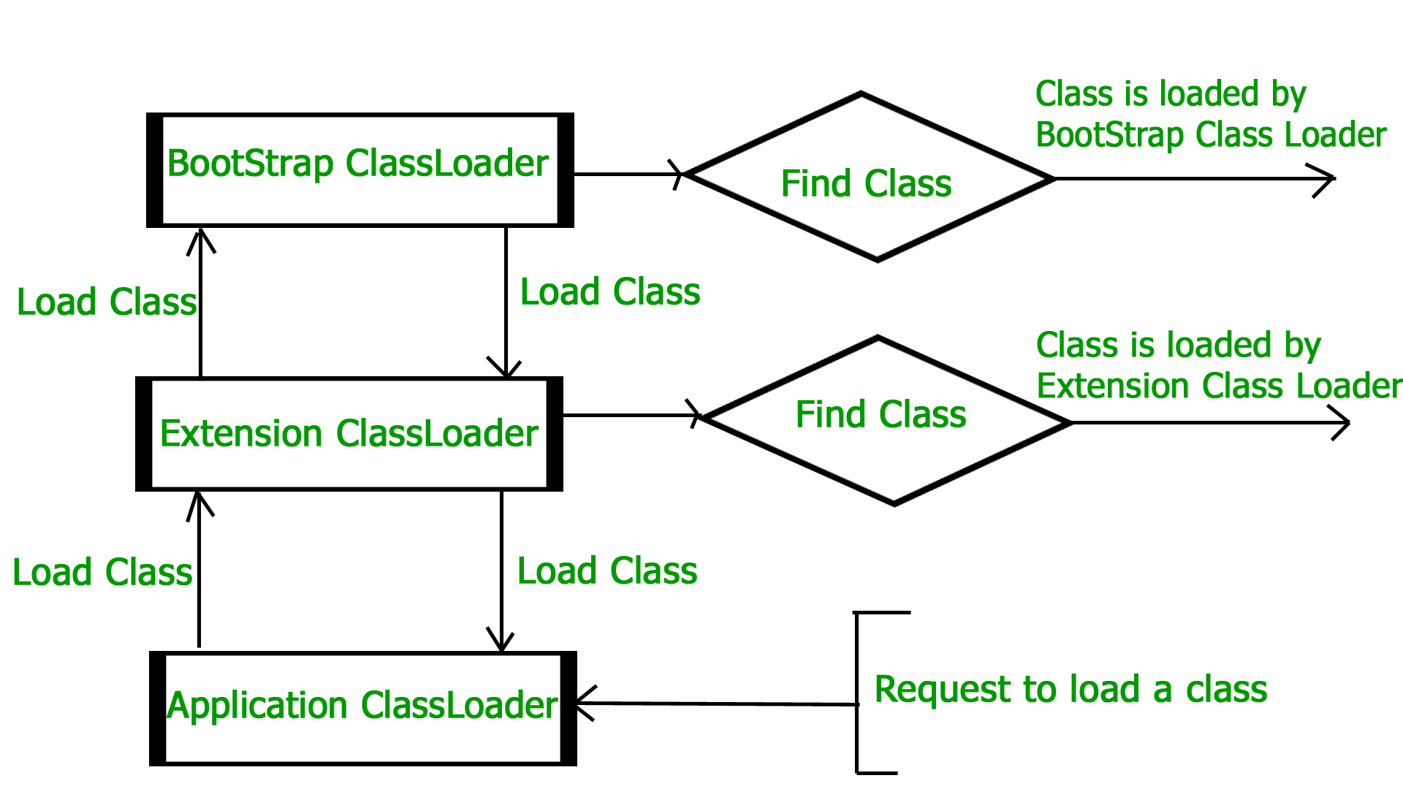
JVM Memory
- Method area: In the method area, all class level information like class name, immediate parent class name, methods and variables information etc. are stored, including static variables. There is only one method area per JVM, and it is a shared resource.
- Heap area: Information of all objects is stored in the heap area. There is also one Heap Area per JVM. It is also a shared resource.
- Stack area: For every thread, JVM creates one run-time stack which is stored here. Every block of this stack is called activation record/stack frame which stores methods calls. All local variables of that method are stored in their corresponding frame. After a thread terminates, its run-time stack will be destroyed by JVM. It is not a shared resource.
- PC Registers: Store address of current execution instruction of a thread. Obviously, each thread has separate PC Registers.
- Native method stacks: For every thread, a separate native stack is created. It stores native method information.

Execution Engine
Execution engine executes the “.class” (bytecode). It reads the byte-code line by line, uses data and information present in various memory area and executes instructions. It can be classified into three parts:
- Interpreter: It interprets the bytecode line by line and then executes. The disadvantage here is that when one method is called multiple times, every time interpretation is required.
- Just-In-Time Compiler(JIT) : It is used to increase the efficiency of an interpreter. It compiles the entire bytecode and changes it to native code so whenever the interpreter sees repeated method calls, JIT provides direct native code for that part so re-interpretation is not required, thus efficiency is improved.
- Who is going to take care whether it is repeatedly required method or Hotspot method ?
- Hotspot Profiler is responsible to identify whether method is repeatedly required ( i.e. it is HotSpot)

- Garbage Collector: It destroys un-referenced objects.

Java Native Interface (JNI) :
It is an interface that interacts with the Native Method Libraries and provides the native libraries(C, C++) required for the execution. It enables JVM to call C/C++ libraries and to be called by C/C++ libraries which may be specific to hardware.
Native Method Libraries :
It is a collection of the Native Libraries(C, C++) which are required by the Execution Engine.

- What is the job done by classloader ?
Ans:- classloader loads the java class. In java , classes are loaded on demand basis i.e. only when u use the class for the first time in ur application, class will be loaded.

- Explain classloaders in java.
Ans:- BootStrapClassLoader is written in native language

ExtensionClassLoader and ApplicationClassLoader they are written in Java.

JVM follows the Delegation-Hierarchy principle to load classes. System class loader delegate load request to extension class loader and extension class loader delegate request to the bootstrap class loader. If a class found in the boot-strap path, the class is loaded otherwise request again transfers to the extension class loader and then to the system class loader. At last, if the system class loader fails to load class, then we get run-time exception java.lang.ClassNotFoundException.

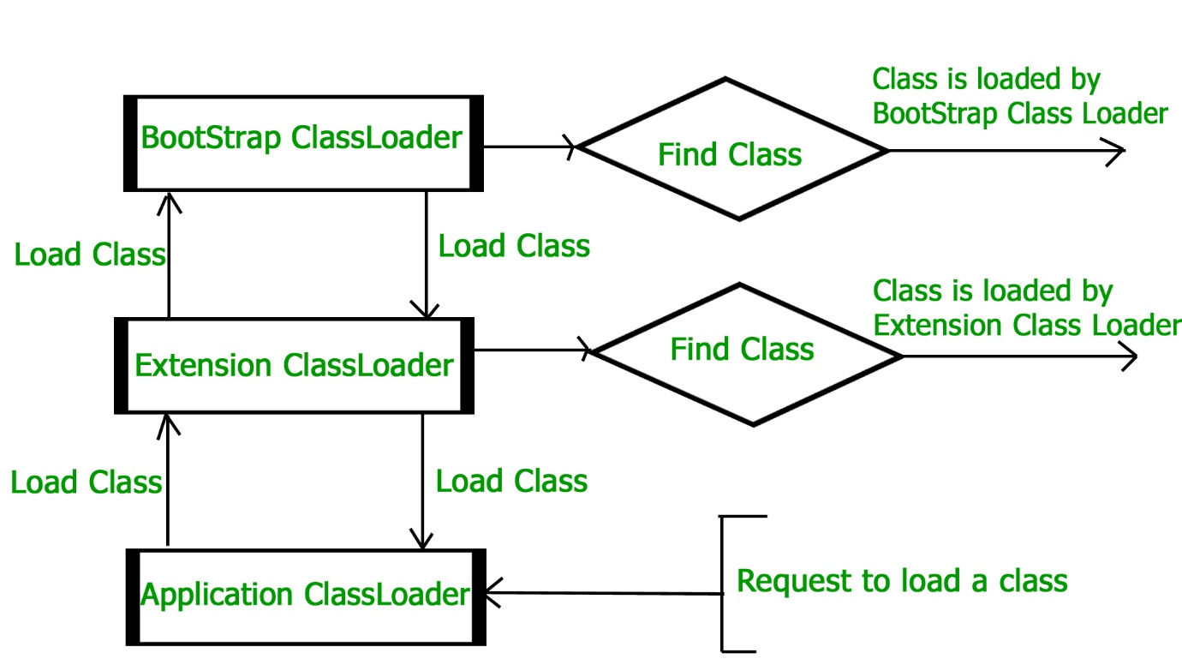

- What is the role played by Bytecode Verifier ?
Ans:- Bytecode Verifier performs verification of bytecodes. When a class loader presents the bytecodes of a newly loaded Java platform class to the virtual machine, these bytecodes are first inspected by a verifier. The verifier checks that the instructions cannot perform actions that are obviously damaging. All classes except for system classes are verified.

- What are the memory areas allocated by JVM ?
Ans:-
a) Class(Method) Area or metaspace(according to java8):
Class(Method) Area stores per-class structures such as the runtime constant pool, field and method data, the code for methods.
b) Heap:
It is the runtime data area in which objects are allocated.
c) Stack:
Java Stack stores frames. It holds local variables and partial results, and plays a part in method invocation and return.
Each thread has a private JVM stack, created at the same time as thread.
A new frame is created each time a method is invoked. A frame is destroyed when its method invocation completes.
d) Program Counter Register:
PC (program counter) register. It contains the address of the Java virtual machine instruction currently being executed.
e) Native Method Stack:
It contains all the native methods used in the application.

- What is the difference between Java compiler ( javac ) and JIT ?
Ans:- javac converts source code into the bytecode whereas JIT converts bytecode into native code.
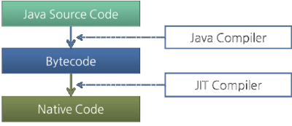

- Is JRE different for different Platforms ?
Ans:- yes

- Difference bet’n C++ and java in terms of object creation.
Ans:- in C++ object can be created on stack as well as on heap (because java has given importance to late binding from the very beginning)

- What is garbage collection ?
Ans:- Automatic garbage collection is the process of looking at heap memory, identifying which objects are in use and which are not, and deleting the unused objects. An in use object, or a referenced object, means that some part of your program still maintains a pointer to that object. An unused object, or unreferenced object, is no longer referenced by any part of your program. So the memory used by an unreferenced object can be reclaimed.

- Can we force garbage collection programmatically?
Ans:- no, we can at the most request for Garbage Collection using “System.gc()” or “Runtime.gc()”.

20) How to request JVM for garbage collection
Ans:- We now know that the unreachable and unusable objects are available for garbage collection but the garbage collection process doesn’t happen instantly. Which means once the objects are ready for garbage collection they must to have to wait for JVM to run the memory cleanup program that performs garbage collection. However you can request to JVM for garbage collection by calling System.gc() or Runtime.gc() method.

- How to use finalized method?
Ans:- Following example demonstrates exactly how we can use “finalized()” method.

public class MyClass
{
public static void main(String args[])
{

/* Here we are intentionally assigning a null
* value to a reference so that the object becomes
* non reachable
*/
MyClass obj=new MyClass();
obj=null;

/* Here we are intentionally assigning reference a
* to the another reference b to make the object referenced
* by b unusable.
*/
MyClass a = new MyClass();
MyClass b = new MyClass();
b = a;
System.gc();
}
protected void finalize() throws Throwable
{
System.out.println("Garbage collection is performed by JVM");
}
}

In the above code we have overridden a finalize() method. This method is invoked just before a object is destroyed by java garbage collection process. This is the reason you would see in the output that this method has been invoked twice.

- What is an alternative for finalized method?
Ans:- It is not recommended to rely on finalized method because of its non-guaranteed behavior but then what is an alternative of releasing resource, performing cleanup because there is no destructor in Java? Having a method like close() or destroy() make more sense for releasing resources held by classes. In fact JDK library follows this. E.g various inputstream and outputstream implementations are having “close()” method to release the resources. In fact it’s one of the best practice to call close method from finally block in java. Only problem with this approach is its not automatic, client has to do the cleanup and if client forgets to do cleanup there are chances of resources getting leaked, which again suggests us that we could probably give another chance to finalize method.
- What is the difference between System.gc() and Runtime.getRuntime().gc() ?
Ans:- Both are same. System.gc() is effectively equivalent to Runtime.gc(). System.gc()internally calls Runtime.gc().
The only difference is System.gc() is a class method where as Runtime.gc() is an instance method. So, System.gc() is more convenient.
If you look at System class source code, it has got following method:
public static void gc()
{
Runtime.getRuntime().gc();
}

- When do u get NullPointerException ?
Ans:- when reference variable containing null and if it’s used to invoke member, we get NullPointerException.

- What is the signature of main function in java ?
Ans:- public static void main(String args[]) or public static void main(String …args)

- Who invokes main() function ?
Ans:- JVM invokes main() function.

- Can we define more than one public class in a java source code ? what is the rule of public class and file name . ?
Ans:- no we can’t define more than one public class in one source file. Name of the public class and the file name must match.

- Difference bet’n path and classpath.
Ans:- path is used for “.exe”,”.dll” and “.bat” files
Classpath is used for “.jar” files.

- What is the rule for local member in java.
Ans:- local member must be initialized before use.

- What is .class file known as ?
Ans:- java bytecode

- How java is strong object oriented ?
Ans:- java does not allow global members, friend function. Everything (variables as well as methods) must be defined inside the class.

- What is finalized() method ?
Ans:- finalize method in java is called before Garbage collector reclaim the Object. It’s last chance for any object to perform cleanup activity i.e. releasing any system resources held, closing connection if open etc. Main issue with finalized method in java is its not guaranteed by JLS that it will be called by Garbage collector or exactly when it will be called, for example an object may wait indefinitely after becoming eligible for garbage collection and before its finalize() method gets called. Because of this reason it make no sense to use finalized method for releasing critical resources finalized. It may work in development in one JVM but may not work in other JVM.
- Why there is no sizeof operator in java ?
Ans:- because size of all the java datatypes is identical across all platforms.

- What kinds of programs u can develop using Java?
There are mainly 5 types of applications that can be created using java:
a) Standalone Application
It is also known as desktop application or window-based application. An application that contain “main” function as an entry point.
b) Applet
It is a java program which can run on java-enabled web browser
c) Web Application
An application that runs on the server side and creates dynamic page, is called web application. Currently, servlet, jsp, struts, jsf etc. technologies are used for creating web applications in java.
d) Enterprise Application
An application that is distributed in nature, such as banking applications etc. It has the advantage of high level security, load balancing and clustering. In java, EJB is used for creating enterprise applications.
e) Mobile Application
An application that is created for mobile devices. Currently Android and Java ME are used for creating mobile applications.

- Difference bet’n C++ pointer and Java reference.
Ans:- similarity bet’n two is both of them store the address of heap based object. Difference is c++ pointer can be incremented, decremented and also can be dereferenced. None of these operations u can invoke on java reference variable.
- U have reference type as a member of class. What is the default value it gets?
Ans:- null

- What are the expressions allowed in switch block of java ?
Ans:- byte,short,int,char and String ( jdk 1.7 onwards)

- In a java source code there are 3 classes define e.g class A{} class B{} and class C{}. When u compile the source code how many .class files u get and what are their names ?
Ans:- A.class, B.classs, C.class

- What is java’s old name ?
Ans:- oak

- What are the technologies come under “Distributed Object System “ ?
Ans:- RMI, CORBA and EJB

- What do u mean by Java Enabled Browser, Web Server and Application Server?
Ans:- Java-Enabled means having “JRE” inside it.

- What is “this”? What is its importance?
Ans:- “this” is a reference to the current object or invoking object. With the help of “this” reference member function comes to know about the invoking object. Actually when u invoke any member function, compiler implicitly passes the “this” reference to the method being invoked.

- What is UnsupportedClassVersion error ?
Ans:- when a upper-version class file is executed in the lower-version JVM, (e.g. javac belongs to 8 and JRE belongs to 1.7 )
java.lang.UnsupportedClassVersionError occurs.

- What is Unicode Character Set in Java ?
Ans:- Since Java is designed to support Internationalization ( I18N ),it makes sense that it would use Unicode to represent characters. Unicode defines a fully international character set that can represent all of the characters found in all human languages. It is a unification of dozens of character sets such as Latin, Greek, Arabic and many more. For this purpose, it requires 16 bits. Thus char in java is 16 bit type. The range of char is 0 to 65535. There are no negative chars.

- Explain Java Execution Flow.
Ans:- Virtual Machine Start-Up

A Java virtual machine starts execution by invoking the method main of some specified class, passing it a single argument, which is an array of strings if provided else an empty array.

For example:
java Test

will typically start a Java virtual machine by invoking method main of class Test .

Load the Class Test

Link Test: Verify, Prepare, (Optionally) Resolve
Linking involves verification, preparation and (optionally) resolution.

Verification checks that the loaded representation of Test is well-formed, with a proper symbol table. Verification also checks that the code that implements Test obeys the semantic requirements of the Java programming language and the Java virtual machine. If a problem is detected during verification, then an error is thrown.

Preparation involves allocation of static storage and any data structures that are used internally by the virtual machine, such as method tables.

Resolution – Symbolic references get replaced with the actual references.

Initialize Test: Execute Initializers
Initialization consists of execution of any class variable initializers and static initializers of the class Test, in textual order. But before Test can be initialized, its direct superclass must be initialized, as well as the direct superclass of its direct superclass, and so on, recursively. In the simplest case, Test has Object as its implicit direct superclass; if class Object has not yet been initialized, then it must be initialized before Test is initialized. Class Object has no superclass, so the recursion terminates here.
If class Test has another class Super as its superclass, then Super must be initialized before Test. This requires loading, verifying, and preparing Super if this has not already been done and, depending on the implementation, may also involve resolving the symbolic references from Super and so on, recursively.
Initialization may thus cause loading, linking, and initialization errors, including such errors involving other types.

Invoke Test.main
Finally, after completion of the initialization for class Test (during which other consequential loading, linking, and initializing may have occurred), the method main of Test is invoked.

The method main must be declared public, static, and void. It must accept a single argument that is an array of strings. This method can be declared as either public static void main(String[] args)
Or public static void main(String... args)

Loading of Classes and Interfaces which are referenced from main() function………

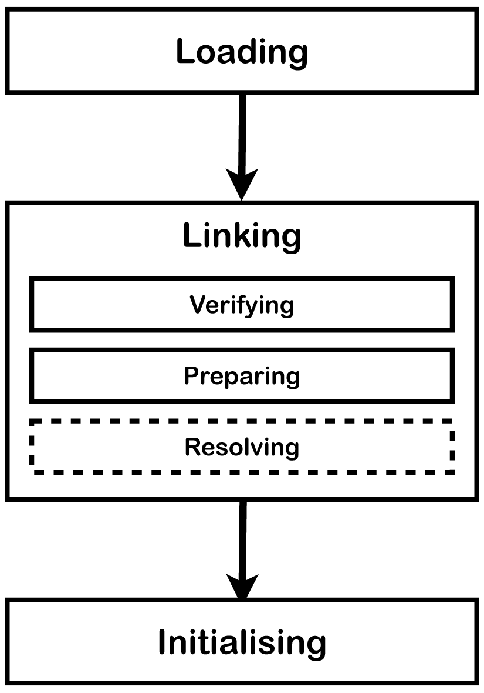

- What is the difference bet’n Lazy and Eager Resolution?
Ans:- e.g. suppose Car class has Engine as a member.
Here if Car has Engine as static member, Engine will be resolved (loaded) as soon as Car is loaded ( Eager ). On the other hand if Car has Engine as non-static member, Engine will be resolved (loaded) only after you instantiate the Car (Lazy).

- Does Java have pass by reference or by value?
Ans:- Java passes everything by value, and not by reference. When we say everything, that means – Primitive types as well as reference types, these are all passed by value in Java.
In case of reference types, what happens is you pass a reference to an object to a method. Inside method it is collected in another reference (formal argument) to that same object.
Now you can modify this formal argument inside the method as much as you want but no matter how hard you try you'll never be able to modify the passed reference that will keep referencing the same Object no matter what!

